MKOREAN SV 7 2025 BOT STRATEGY
SV 7 BOT is an AI bot working best on Over Under Market and some bit of Matches. The bot only function mkoreanwwn.com site available on GOOGLE CHROME. It doesn’t in a DERIV so that it can reduce the habit of selling this free bot.
Features of SV 7 bot
- It has two prediction sites.
- It has block for inserting your entry point.
- It has a stop loss and take profit working efficiently.
- It’s fast and accurate.
What to consider in SV 7
Avoid Green bar at digit 8 or Digit 9 to avoid pulling to moving cursor to digit above 7 that is 7, 8 and 9 .
How does MKOREAN SV 7 bot works
Strategy for Beginners in SV 7
Set bot to this settings
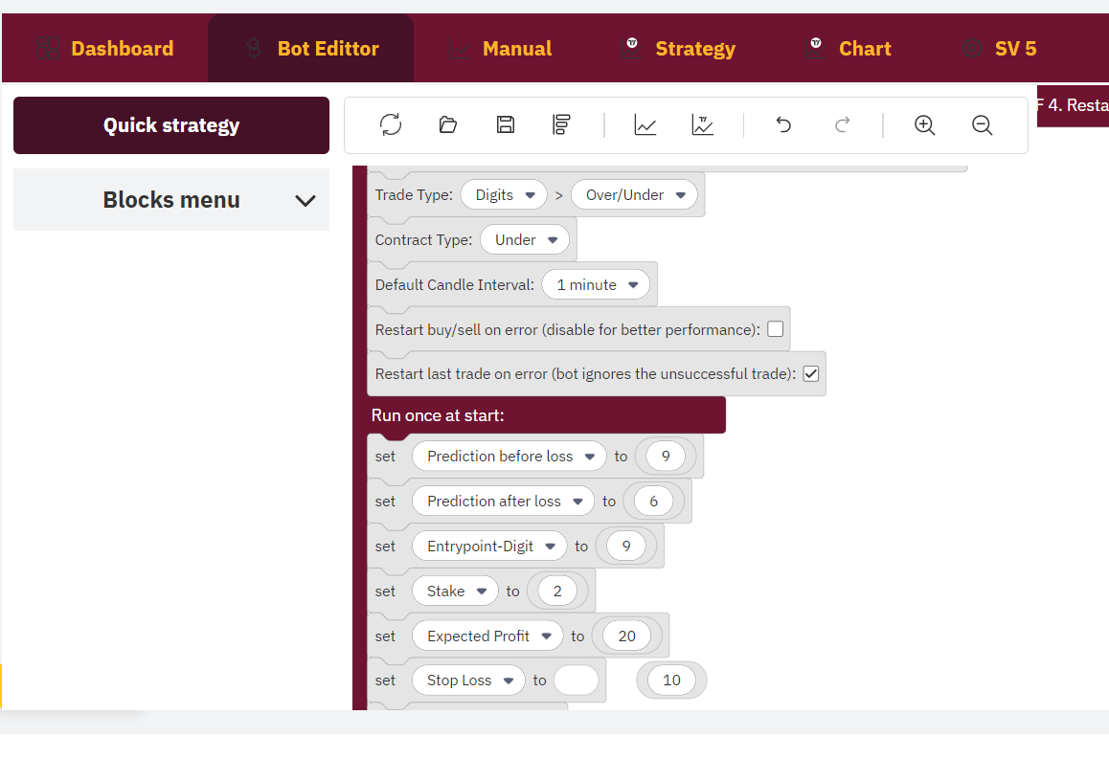

After setting (it’s means)
You’re trading UNDER 9
Then after loss it will it trade UNDER 6
After a loss it add 0.01 USD to your stake then after two wins it returns to your normal stake.
Incase of two consecutive losses, there will be a martingale to recover your losses.

Strategy for SV 7 bot for a Deriv pro
Set your bot to this settings
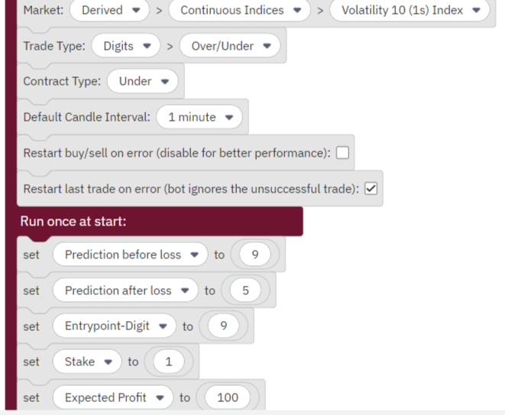

After setting (it’s means)
You’re trading UNDER 9
Then after loss it will it trade UNDER 5
After a loss it add 0.01 USD to your stake then after two wins it returns to your normal stake.
In case of two consecutive loss, there will be a martingale to recover your losses.

Requirements for Deriv pro’s
Make sure green bar at digits less than 5 and your entry point be obviously digit 9.

THE END

It’s always Mnyamaa incase of anything just contact me via WhatsApp 0727 835 080 only

